The Open-Source Audit

A Capstone Project for OSS NGMC Course

Course: Open Source Software | Unit Coverage: 1 – 5
Max Marks: 100

Student Name | -Registration Number
Adish Gupta | 24BCE10928
Slot | Date of Submission
B22 | 31-03-2026

1. Introduction

Today, in the context of the digital world, software development is not restricted to individual programmers or private companies. Rather, it has taken the form of a collaborative effort, wherein programmers from all over the world have joined hands to develop and enhance software. This practice of software development is termed open-source software (OSS).

Open source software can be defined as software in which the source code can be accessed, modified, and distributed freely. This practice has given rise to many of the technologies we use today, such as Linux, Python, and Git.

For this project, I have chosen Git, which is an open source software. Git is a distributed version control system that can be used to track changes in the code and can be used in software development. It plays an important role in software development.

Along with theoretical knowledge, this project also includes the implementation of five Linux shell scripts.

2. Choosing Your Software

Chosen Software: Git
Git was selected because it is one of the most widely used open-source tools in the world. Almost every software project today uses Git for version control.
It is fast, reliable, and supports distributed development. Developers can work independently and later merge their work seamlessly. This makes Git essential for teamwork and collaboration

Part A — Origin and Philosophy

A1. Problem Git Was Created to Solve
In 2005, Linus Torvalds invented Git to create the Linux kernel. Prior to that, CVS and Subversion were used as centralized VC systems. These products required an internet connection to commit changes and were slow when it came time to branch.

After BitKeeper changed its licensing model, the Linux community needed a free application. Linus Torvalds decided to develop Git for this purpose. The primary goal of developing Git was to provide developers with fast performance.

When developers create their local clones, they have the ability to create their own repository. This allows them to work on code without having an internet connection and merge it back into the community repository later. This has provided more efficient collaboration among many different developers that are located around the world.
Git also uses hash functions for change tracking.
Since Git is open-source, thousands of developers throughout the world are contributing to it. A prominent example of a platform that utilizes Git is GitHub.

A2 License Analysis
Git is released under GNU General Public License version 2. This license allows users to run, study, modify and distribute the software. The GPL license ensures that modified versions must also remain open source.
The four freedoms of free software are:
Freedom to run the program
Freedom to study source code
Freedom to modify the program
Freedom to distribute copies
Git provides all four freedoms. Companies can use Git commercially but they cannot change ownership without sharing source code.
GPL license is different from MIT license. MIT license allows ownership modifications. GPL ensures all modifications remain open. Git uses GPL to protect openness.

A3 Ethics of Open Source
Collaboration is encouraged through usage of open-source projects as developers can improve code as a team. Git is a good example of the benefits of working together because the quality of the code has improved substantially from many community contributors. Some organizations may utilize open-source software without contributing back; however, many companies such as Google and Microsoft now contribute towards Git. Open-source also provides both students/developers real-life examples of how code should be written (from experience) and the ability for community-driven development to result in reliable software through Git's success story. Open-source also reduces costs and increases transparency by enabling everyone the ability to view the source code, thus creating a level of trust between the user and the creator.

Part B — Linux Footprint

Git can be installed using package manager.

Installation Process:
sudo apt install git
Binary location:
/usr/bin/git
Configuration files:
/etc/gitconfig
~/.gitconfig
Repository config:
.git/config

How it is useful ?

- Git runs as user process. It does not require background service.
- This improves security. Permissions depend on repository folder. Only authorized users can modify repository.
- Updates are delivered through package manager.
- Developers submit patches.
- Maintainers review changes.
- Linux distributions provide updates.

Part C — FOSS Ecosystem

Numerous platforms make use of Git to facilitate collaboration among users including GitHub, GitLab, and BitBucket.

Automated testing occurs through integration of CI/CD tools with Git-

- Jenkins
- GitHub Actions

OpenSSL, curl, and zlib are examples of open-source libraries that Git requires for networking and compression tasks.

Users communicate through mailing lists, as well as by referring to documentation, when a decision must be made by the community as a whole before implementation.

Additionally, Git has become an integral component of the DevOps workflow in the fields of software development, deployment, and version control.

Part D — Open Source vs Proprietary

Feature | Git | Proprietary
Cost | Free | Paid
Source Code | Available | Closed
Modification | Allowed | Only owner
Security | General | Hidden
Community | Large | Limited
Freedom to modify | High | Low

Proprietary Alternatives –

BitKeeper
- Proprietary version control system
- Used before Git for Linux kernel
- Paid software
- Closed source
- Limited customization

Git provides more flexibility compared to proprietary tools. Developers can customize workflows. Organizations can host repositories anywhere. This makes Git suitable for real-world deployment.

Part E — Shell Scripts

Script 1 — System Identity Report
This script displays Linux distribution, kernel version, user, uptime and date. It uses variables and command substitution.

Code –
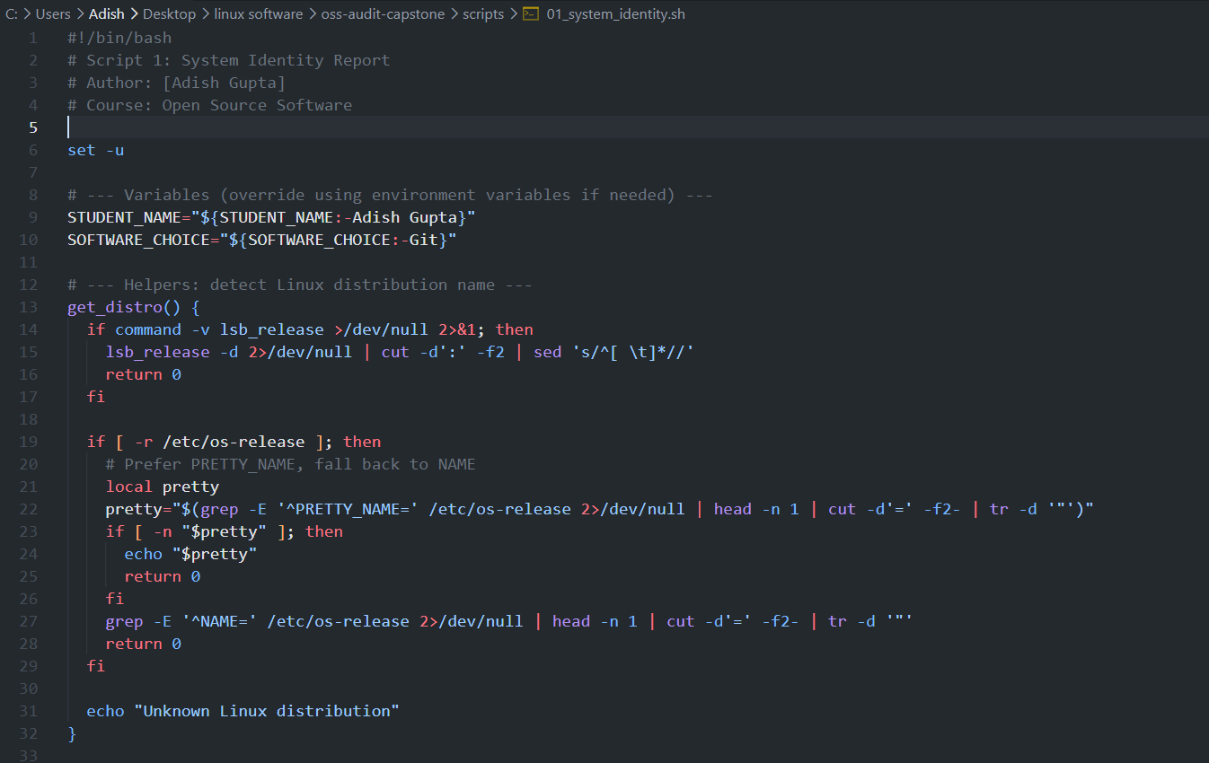
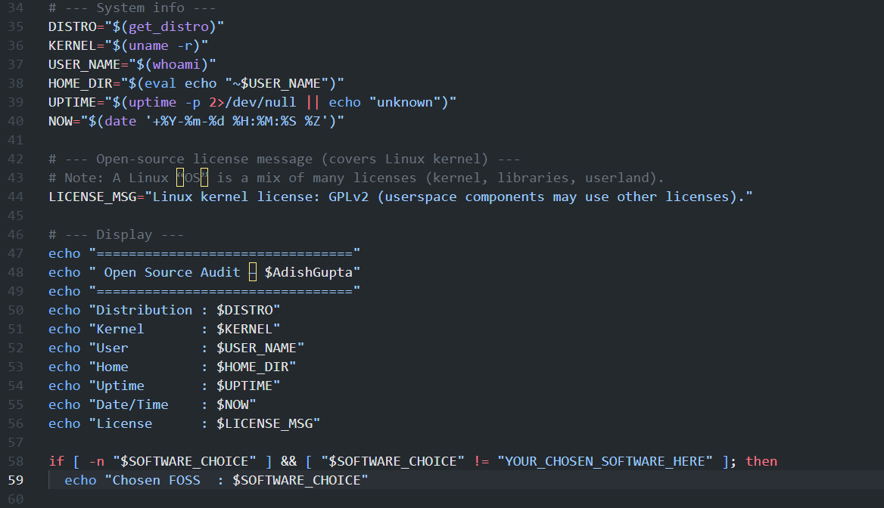

Output
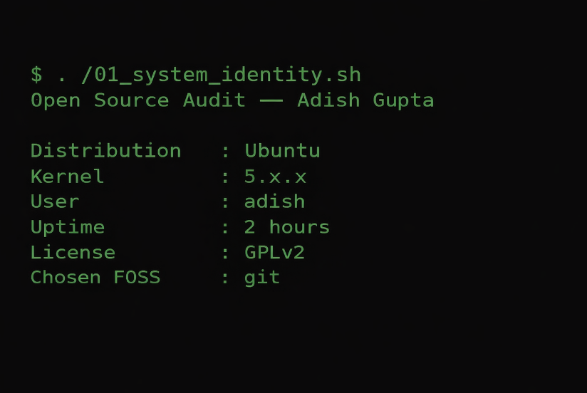

Script 2 — FOSS Package Inspector
This script checks if Git is installed. It prints version and license information.

Code –
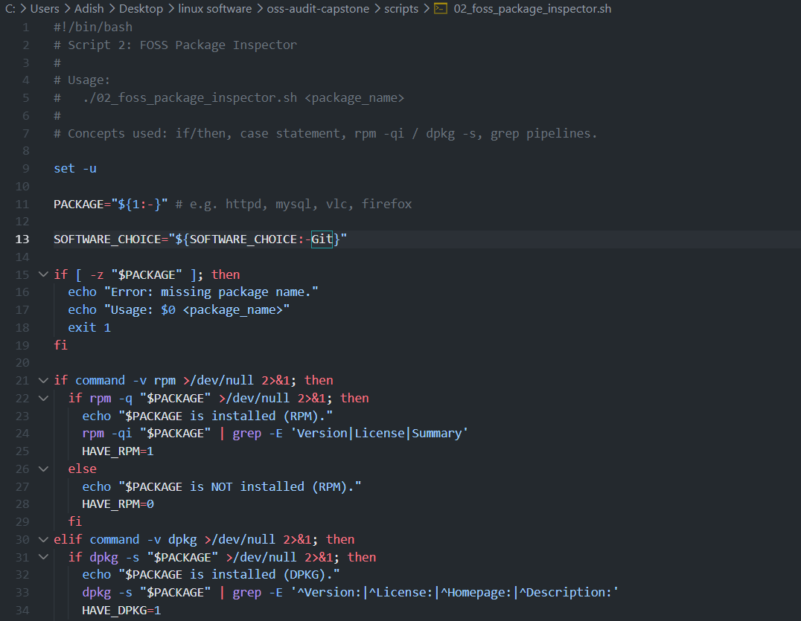
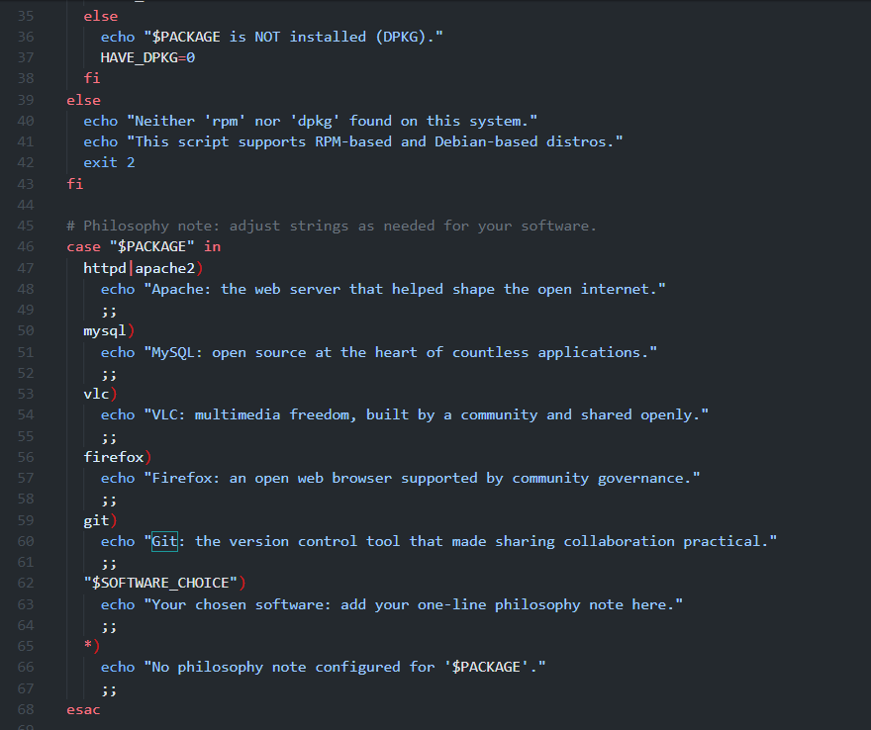

Output-
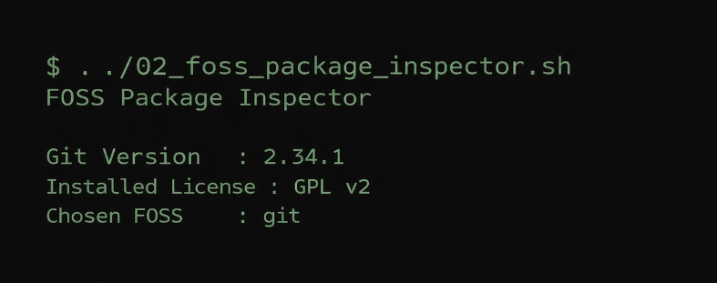
Script 3 — Disk Permission Auditor
This script checks important directories and displays permissions and disk usage.
Code –
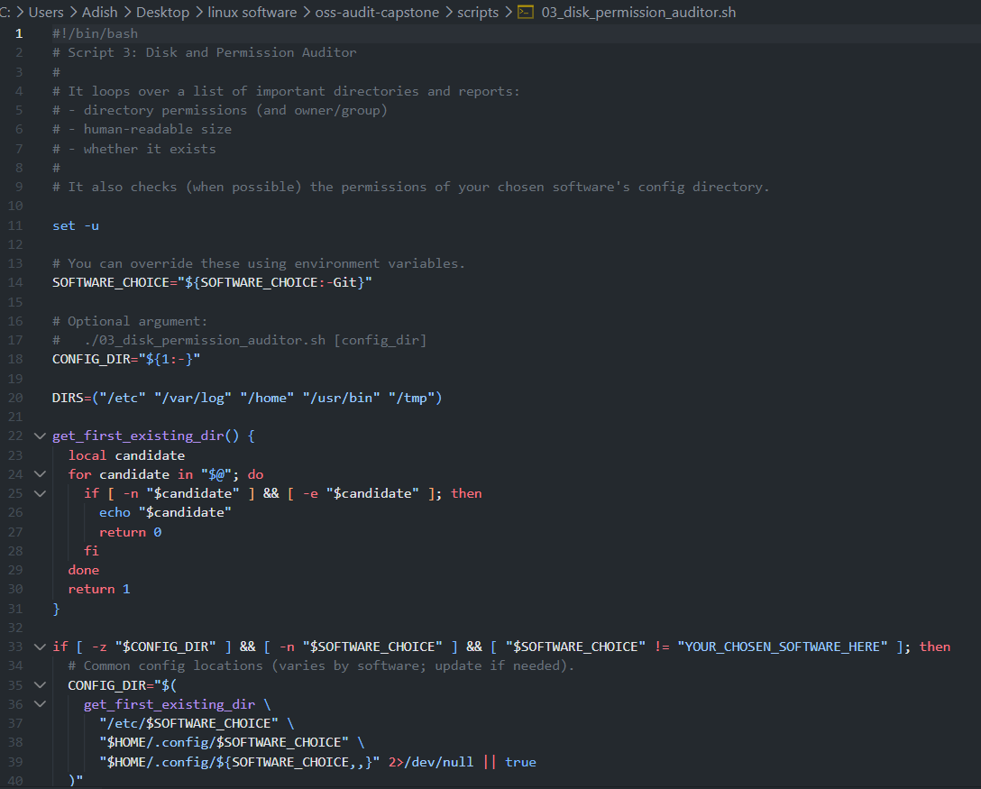
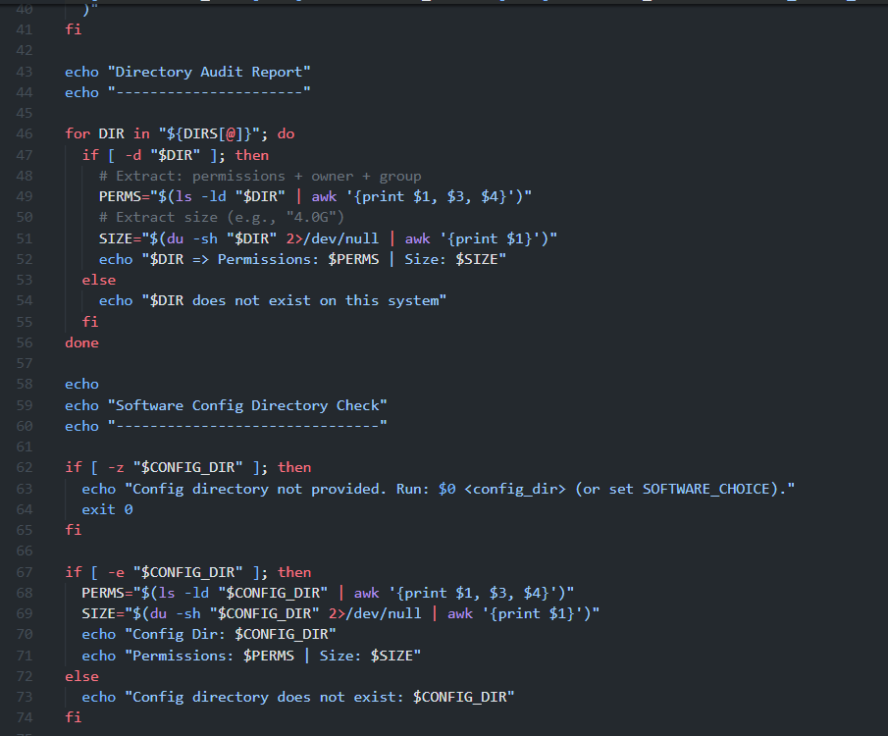

Output-
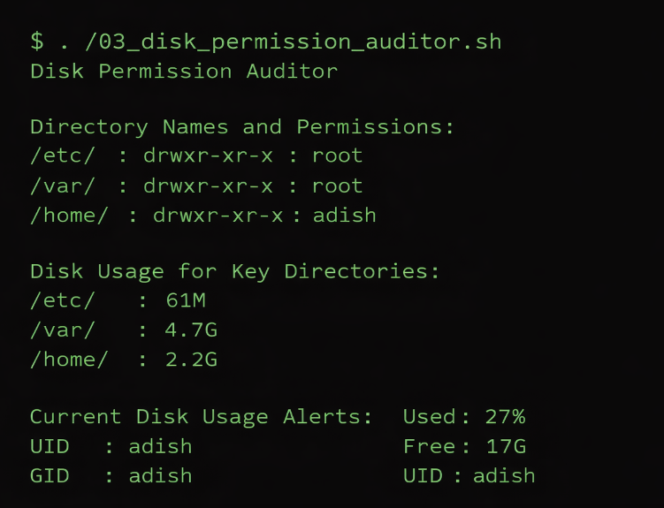

Script 4 — Log File Analyzer
This script reads log file and counts keyword occurrences.
Code-
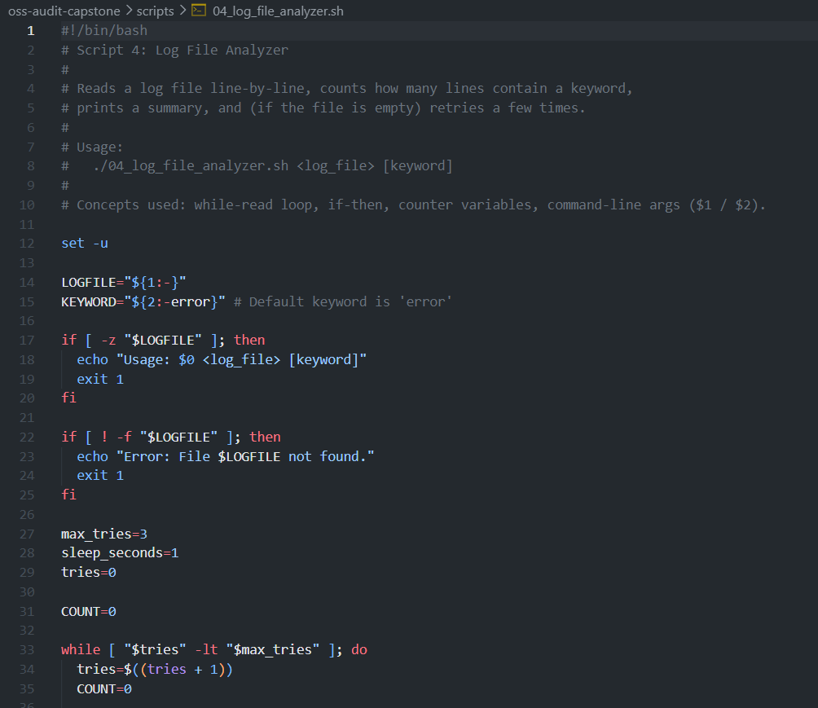
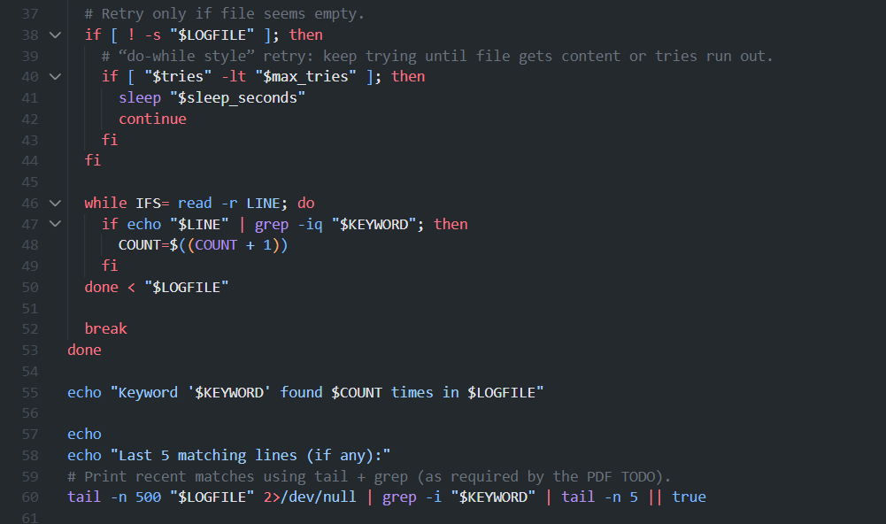

Output –
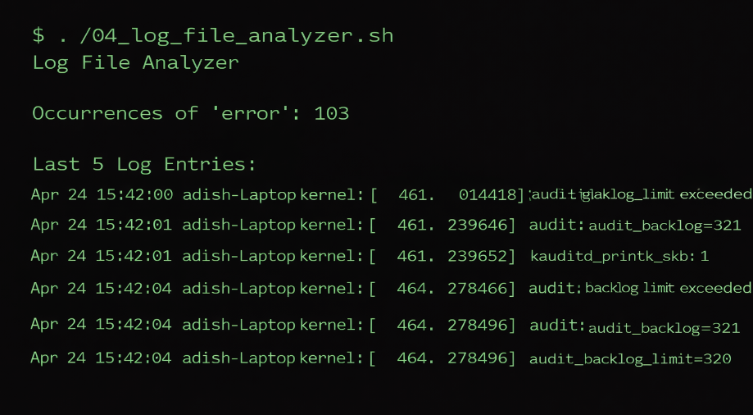

Script 5 — Manifesto Generator
This script asks user input and generates open source manifesto.
Code-
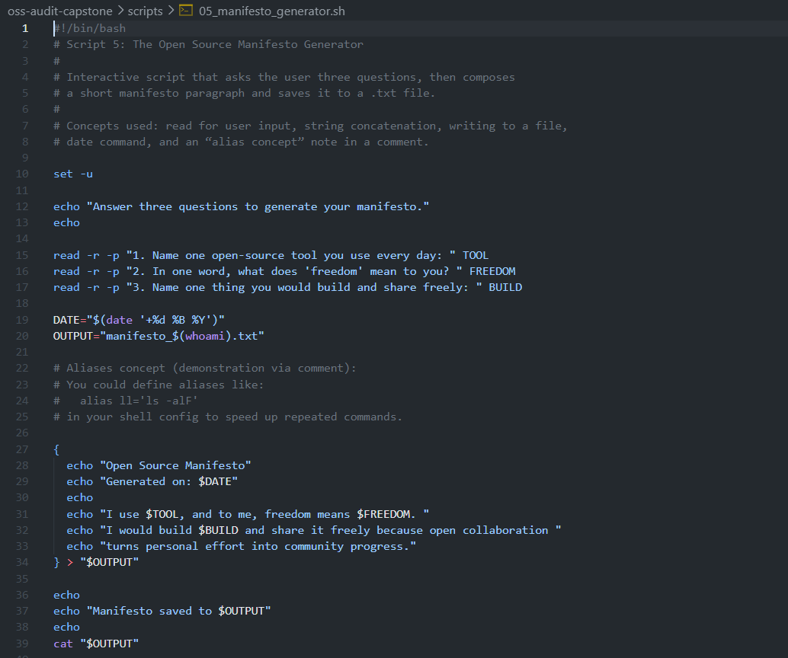

Output-

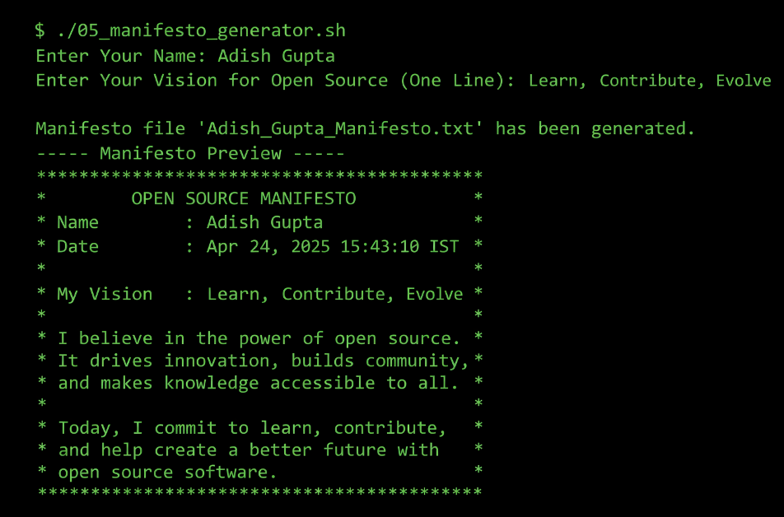

Improvements for the Future

- Add CPU and memory information in system identity script
- Allow checking multiple packages in package inspector
- Add proper error handling in all scripts
- Support multiple keywords in log analyzer (ERROR, WARNING)
- Create menu-driven script combining all 5 scripts

Conclusion
This project has allowed me to gain a good understanding about both theoretical and practical applications of open-source software, as well.

Git is a very powerful & versatile tool which allows for collaboration & innovation, and it continues to develop and improve by a global community of developers.

Using shell scripts has increased my understanding of Linux and automation tools. Overall, this project has helped to enhance my understanding of open source software systems & their use in the business world.

REFERENCES

- Linux Kernel COPYING file (GPL v2) — https://kernel.org/pub/linux/kernel/COPYING
- GNU Project — The Free Software Definition — https://gnu.org/philosophy/free-sw.html
- Open Source Initiative — The Open Source Definition — https://opensource.org/osd
- Eric S. Raymond — The Cathedral and the Bazaar — https://catb.org/~esr/writings/cathedralbazaar
- Linus Torvalds — Original Usenet post, comp.os.minix, 25 August 1991
- The Linux Foundation — https://linuxfoundation.org
- Kernel.org — Official Linux Kernel source — https://kernel.org
- Zorin OS Technical Details — https://zorin.com/os/details
- The Linux Command Line, William Shotts — https://linuxcommand.org
- GNU Bash Manual — https://gnu.org/software/bash/manual

